ANALYSIS
INTRODUCING THE INITIAL STEPS:

#load the packages
library(ggplot2)
library(dplyr)

#loading the Dataset
hrm<-read.csv("C:\\Users\\Savvy Sahai\\Downloads\\HR final.csv")

#Structure of the Dataset
str(hrm)

Output of the above structure:
'data.frame': 14999 obs. of 10 variables:
$ satisfaction_level : num 0.38 0.8 0.11 0.72 0.37 0.41 0.1 0.92 0.89 0.42 ...
$ last_evaluation : num 0.53 0.86 0.88 0.87 0.52 0.5 0.77 0.85 1 0.53 ...
$ number_project : Factor w/ 6 levels "2","3","4","5",..: 1 4 6 4 1 1 5 4 4 1 ...
$ average_montly_hours : int 157 262 272 223 159 153 247 259 224 142 ...
$ time_spend_company : int 3 6 4 5 3 3 4 5 5 3 ...
$ Work_accident : int 0 0 0 0 0 0 0 0 0 0 ...
$ left : Factor w/ 2 levels "True","False": NA NA NA NA NA NA NA NA NA NA ...
$ promotion_last_5years: int 0 0 0 0 0 0 0 0 0 0 ...
$ sales : chr "sales" "sales" "sales" "sales" ...
$ salary : chr "low" "medium" "medium" "low" ...

OBJECTIVE 1 :
Satisfaction level Histogram

Employee satisfaction definition is a term that is used to describe if employees are happy and fulfilling their desires and needs at work. The crucial factor with employee satisfaction is that satisfied employees must do the job and make the contributions that the employer needs.

p1<-ggplot(aes(x=satisfaction_level),data=hrm) +
geom_histogram(color="black",fill="red",bins = 30) +
labs(title="Satisfaction level Histogram", x='Satisfaction Level of Employees', y="Frequency")
p1

The graph is a histogram of the "satisfaction_level" variable, which shows the frequency of different levels of employee satisfaction.
The graph is stored in a variable named "p1" and is created using the "ggplot" function.
The "aes" function is used to map the variable "satisfaction_level" to the x-axis. The "geom_histogram" function is used to create the histogram, with 30 bins(bars) and red color for the bars.
The "labs" function is used to add a title and axis labels to the graph.
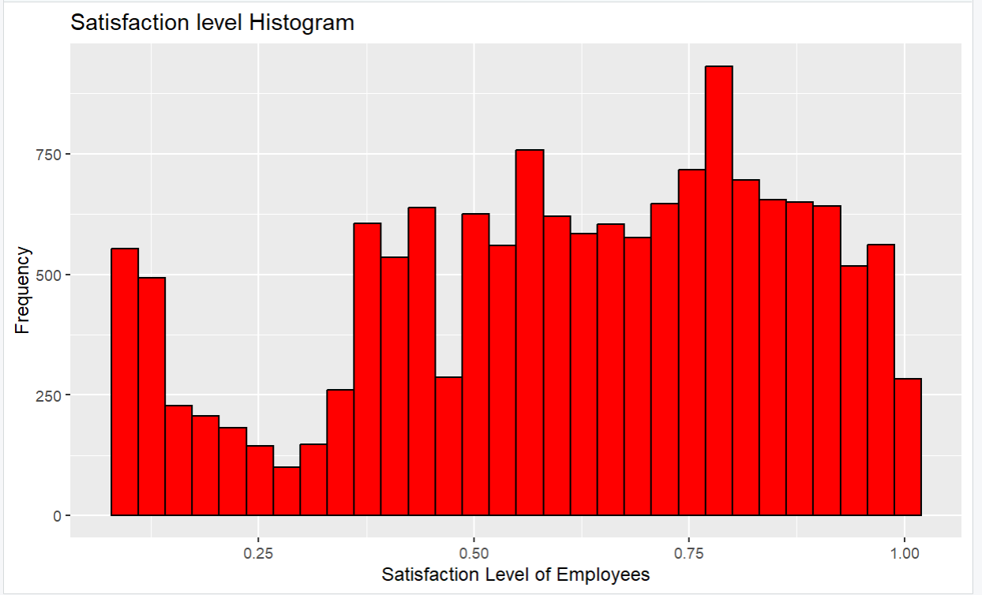

OBJECTIVE 2:
Analysis on number of Projects
To understand how many projects were undertaken by the employee(frequency)
The graph is a bar plot of the "number_project" variable, which shows the frequency of different numbers of projects that employees worked on.
Before creating the graph, the "number_project" variable is converted to a factor using the "factor" function.
The graph is created using the "ggplot" function, with the "aes" function used to map the "number_project" variable to the x-axis.
The "geom_bar" function is used to create the bars, with black color for the outlines and a dark green shade for the bars. The "labs" function is used to add a title and axis labels to the graph.

hrm$number_project<-factor(hrm$number_project)
ggplot(aes(x=number_project),data = hrm) +
geom_bar(color='black',fill='#234338') +
xlab("Number of Projects") + ylab("Frequency") +
labs(title="Barplot of Number of projects")

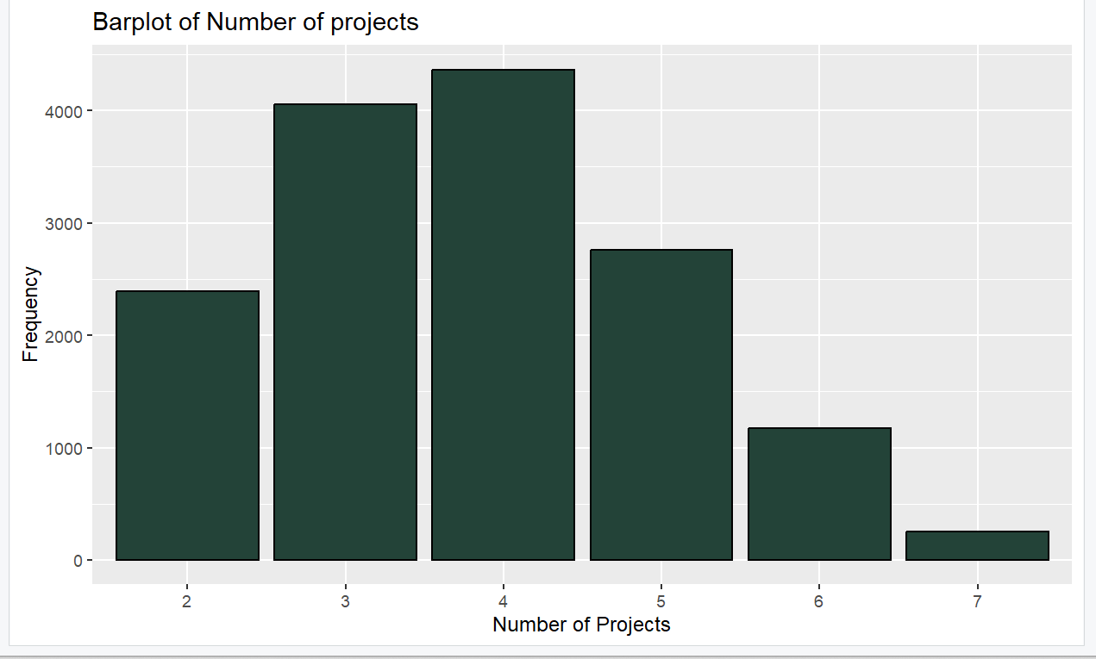

OBJECTIVE 3:
Analysis for variable Time spend at company
The graph is a bar plot of the "time_spend_company" variable, which shows the frequency of different numbers of years that employees spent in the company.
The "table" function is used to create a frequency table of the variable before creating the graph.
The graph is created using the "ggplot" function, with the "aes" function used to map the "time_spend_company" variable to the x-axis.
The "geom_bar" function is used to create the bars, with purple color for the bars. The "labs" function is used to add a title and axis labels to the graph.

table(hrm$time_spend_company)
ggplot(aes(x = factor(time_spend_company)),data = hrm) +
geom_bar(fill = 'purple',color='black') +
xlab("Time spend at compnay in years") +
ylab("Frequency")+
labs(title = "Barplot of Time spend at Company")

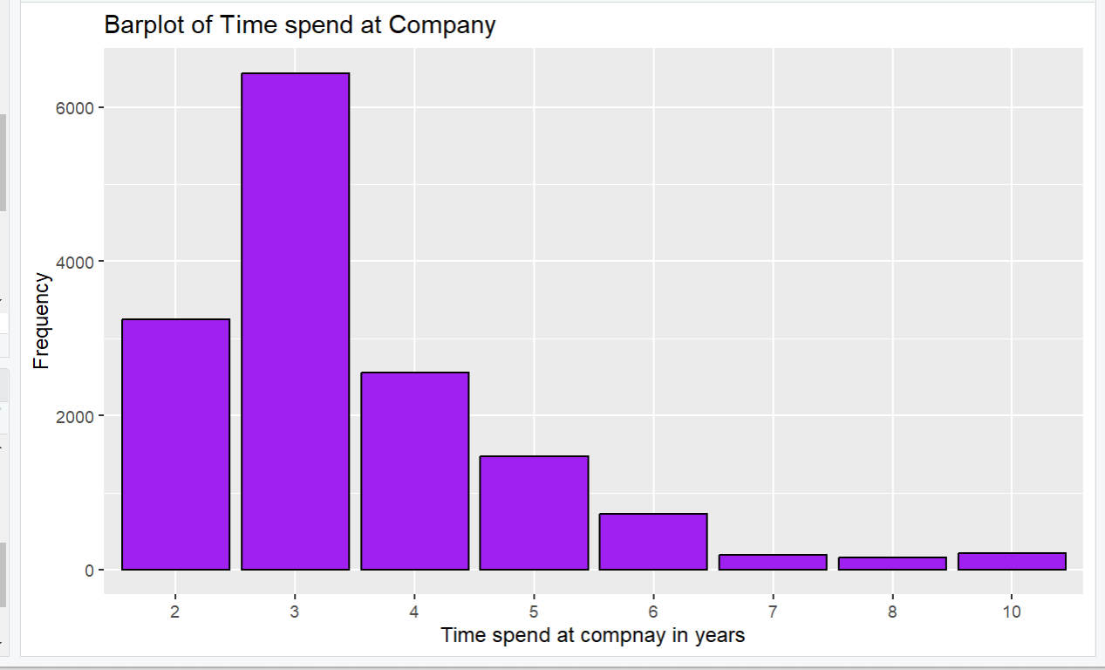

OBJECTIVE 4 :
Analysis of Department of Work
The graph is a bar plot of the "sales" variable, which shows the frequency of different departments in the company.

The "ggplot" function is used to create the graph, with the "aes" function used to map the "sales" variable to the x-axis.

The "geom_bar" function is used to create the bars, with no fill color specified, so it uses the default colors.
The "coord_flip" function is used to flip the x and y axes to make it easier to read the department names.
The "labs" function is used to add axis labels and a title to the graph.

ggplot(aes(x =sales),data = hrm ) +
geom_bar() + xlab('Department') +
ylab('Counts') +
coord_flip()
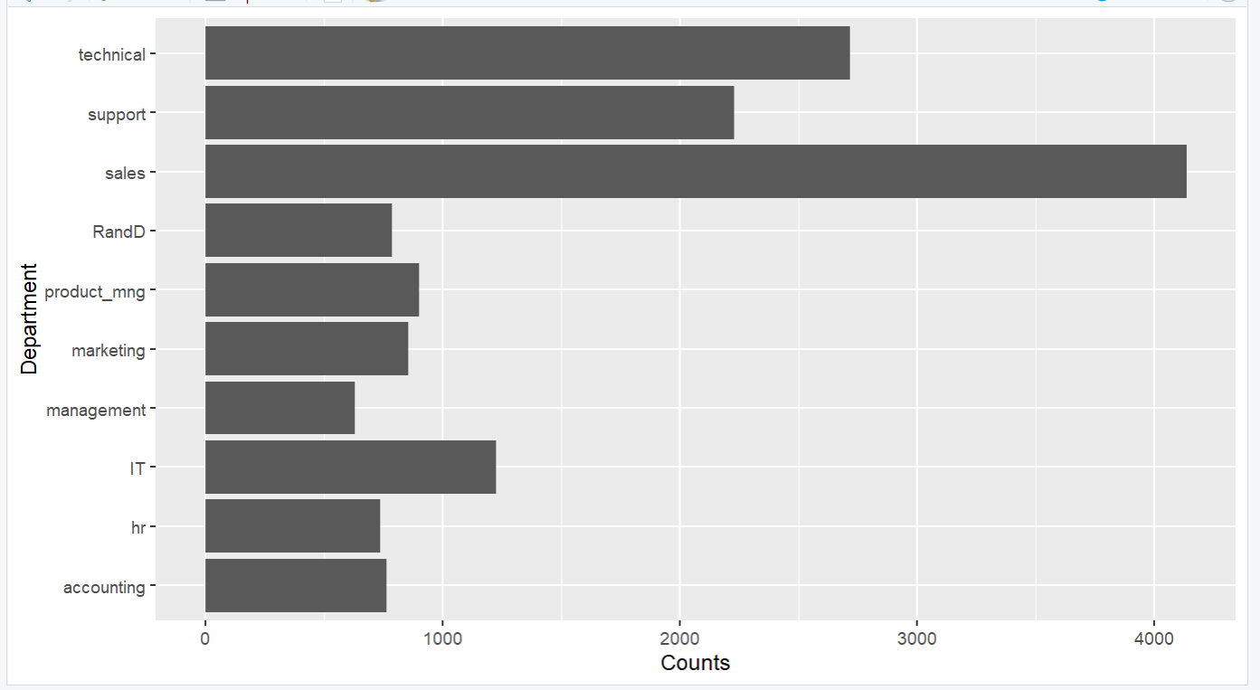

OBJECTIVE 5 :
Department vs Work Accident
This is a scatter plot where each point represents a department in the sales column, and the color of the point indicates whether a work accident occurred (blue for no, red for yes).
The position_jitter function is used to add some jitter to the points to make them easier to see.
The geom_smooth function adds a line of best fit to show the trend between the two variables.
The scale_y_continuous function changes the labels on the y-axis to "No" and "Yes" instead of 0 and 1.
Finally, the theme_classic function changes the theme to a simple white background with black axis lines.

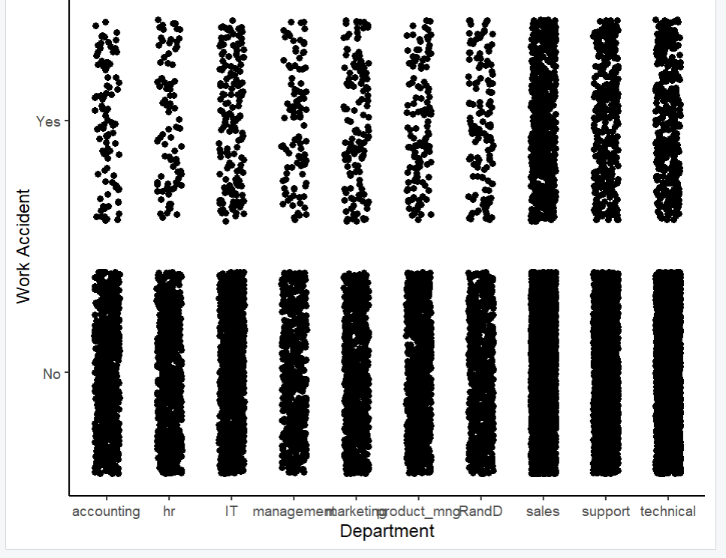
DASHBOARD
